Cycle A – Twenty-Ninth Sunday in Ordinary Time – Oct. 18, 2026

World Mission Sunday

“Give to Caesar things that are Caesars and to God things that are God’s”

OPENING PRAYER (Psalm 96)

Leader: Give the Lord glory and honor.
All: O sing to the Lord a new song; sing to the Lord, all the earth.
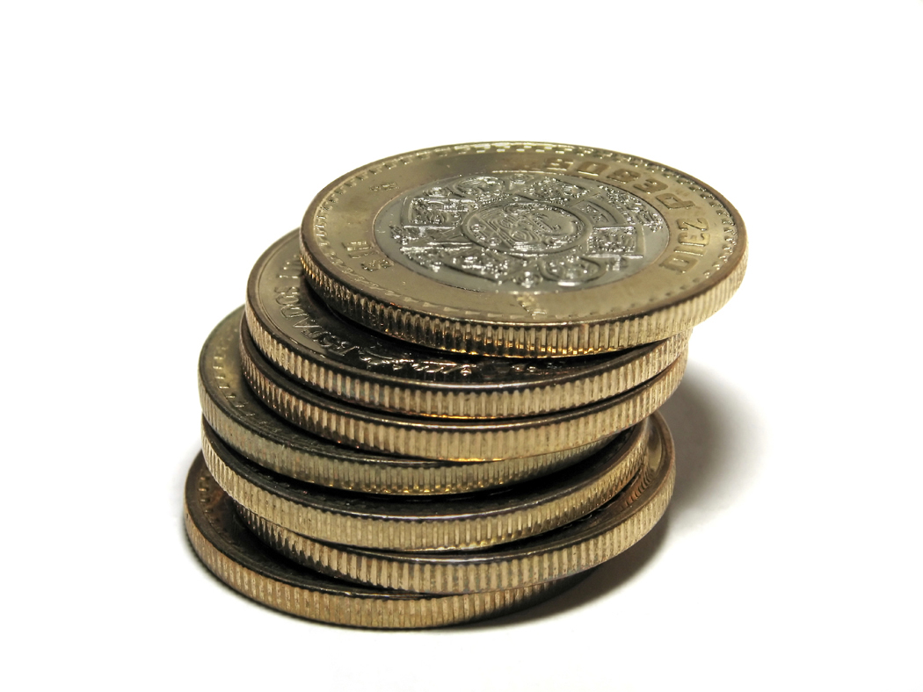Leader: Declare God’s glory among the nations
God’s marvelous works among the peoples.
All: For great is the Lord, and greatly to be praised;
to be revered above all gods.
Leader: Worship the Lord in holy splendor. Amen.

First Reading – Isaiah 45:1, 4-6

King Cyrus was a tolerant Persian emperor who sent the exiled people back to Jerusalem and authorized the rebuilding of the temple. Therefore, Isaiah acclaims Cyrus as a kind of messiah, an anointed king. Cyrus does not worship the God of Israel, but was certainly God’s instrument

- How would the exiles of Israel have responded to Cyrus’ decree?
- Is history truly at God’s disposal?
- Can people be God’s servants unwittingly?
- Cyrus was a Gentile. What does this fact say about God’s plan of salvation?
- Has anyone who does not share our faith ever played a vital role in your/our life?

Second Reading – 1 Thessalonians 1:1-5ab

Thessalonica had been an important seaport since its founding some 300 years before Christ. It is located on the great Roman road that crossed the Balkans. Paul arrived there in answer to an invitation given to him by a vision. A large Jewish community was established in Thessalonica, but it was the Gentiles who welcomed Paul’s preaching. Paul became embroiled in controversy in the synagogue and was forced to leave. Paul sent Timothy back to see how those who accepted the gospel were doing, and Timothy’s report is included farther on in this letter (3:18). The rest of the first letter to the Thessalonians records Paul’s reaction to the good news that Timothy brough,t and addresses some problems that the new converts had, concerning part of Paul’s preaching. It is this that led Paul to write a letter and set the style for all the letters he would come to write. This is the first letter Paul wrote (or at least the first that has been preserved) and the earliest writing in the whole of the New Testament.

- What is Paul’s prevailing mood in this passage?
- Would Paul be able to write these words to us today?
- Is there a particular group, or even an individual, to whom we might address these words?

Gospel: Matthew 22:15-21

The Roman Empire in Christ’s time was deemed to include the entire civilized world. Some welcomed Rome’s rule, others seethed with resentment. The Roman leader Pompey captured Jerusalem in 63 BC and levied an excessive tax. The taxes were a constant and painful reminder of the people’s subjugation. Local individuals were hired by the Roman officials and made their living by collecting taxes from other Jews. Therefore, these tax collecters were viewed as collaborators with the enemy. The coin bore the profile of the Emperor Tiberius. Around the edge it read: “Tiberius Caesar, Son of the Divine Augustus.” Jesus’ reply was like saying: “Well if this is Caesar’s face and name on the coin, it must belong to him. You better give it back to him.”

- What belongs to God? How is it given back to Him?
- What challenge does Christ’s final reply offer us?
- How should Christians behave when it comes to their duties as citizens of a country?

LIVING THE WORD

What is God’s challenge for us this week?

PRAYING THE WORD

Intercession: For Christians engaged in politics. May they act for the good of all by staying faithful to the one true God and enact policy that respects all life, we pray to the Lord.

(Invite personal intentions, ending with “Our Father…”)

Concluding Prayer:

Leader: God our loving Creator, you invite us, in the Psalm, to sing a new song.

All: We pray to You: May this new song not be merely a hymn on our lips but the offering of our lives to the service of others.

Leader: May your will be done
even by those who do not know You or believe in You.

All: May the peoples praise you, O Lord, may all the people praise you.
Amen.

Leader: Let us share with one another a sign of Christ’s peace.

