Cycle A – Twenty-Fourth Sunday in Ordinary Time – Sept. 13, 2026

“… seventy-seven times …”

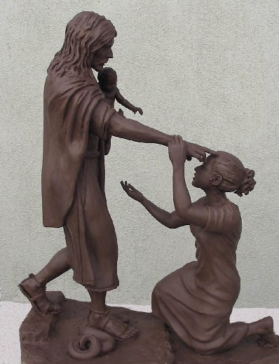OPENING PRAYER (Psalm 103)

Leader: Bless the Lord, O my soul, and all
that is within me, bless his holy name.

All: Bless the Lord, O my soul,
and do not forget all his benefits.

Leader: It is the Lord who forgives all our iniquity,
who heals all our diseases,

All: who redeems our life from the pit,
who crowns us with steadfast love and mercy.
Amen.

Gospel Reading – Matthew 18:21-35
In echoing Sirach’s words from the first reading, Jesus makes his point very bluntly in this parable: the indispensable condition for being forgiven is to forgive others. This is a perennial warning to the church, then and now, that the ultimate value does not lie in displaying an inflexible law-driven rigidity, but in a generous spirit of love and joy which calls forth an equally generous response in others.

- How often have you had to forgive another in your lifetime?
- What do you find the hardest about forgiving another?
- Have you ever felt bound by another’s unforgiveness toward you?

LIVING THE WORD

Make a commitment this week to pray for a more forgiving attitude toward someone whose actions you find yourself judging.

PRAYING THE WORD

Intercession: We pray for those who live in the prison of an unforgiving and cold heart, for those who suffer under the burden of Third World Debt, and for those rich countries urged to forgive these debts. We pray to the Lord.

(Invite personal intentions, ending with “Our Father…”)

CONCLUDING PRAYER

All: Father of mercy beyond imagining,
Your Son, in both deed and word
teaches us to forgive over and over again.

Fill us with you reconciling grace,
so that, rather than holding on to our anger and resentment,
we will forgive, from the heart, those who have wronged us.
We ask this through Christ our Lord.

Amen!

SIGN OF PEACE

Leader:
Renewed in our commitment to forgive always, as we have been forgiven, let us offer each other a sign of Christ’ peace.

