Cycle A – First Sunday of Advent – Nov. 30, 2025

“One will be taken, and one will be left …”
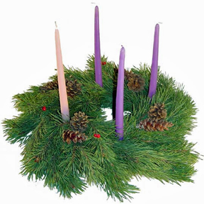
OPENING PRAYER (Psalm 122)

Leader: I rejoiced when they said to me,
“Let us go to the house of the Lord!”

All: And now our feet are standing
within your gates, O Jerusalem!

Leader: Pray for the peace of Jerusalem:
“May they prosper who love you,

All: Peace be within your walls,
and security within your towers.” Amen

LISTENING TO THE WORD

Gospel – Matthew 24:37-44
Jesus’ call to keep awake is a stark reminder that Advent/ Christmas, are not simply seasons of pregnancy and a little baby in swaddling clothes. Beginnings are always tied up with endings, and the “end of time” is prefigured in the birth of God’s Son. Following on the heels of the end-time readings in November ending the church year, these readings want to make sure that we do not slack off and become complacent. Although the arbitrariness of who will be taken and who will be left feels disconcerting, the Christian imperative to live “honourably” as Paul summons us, will make these words both consolation and warning. If we are living as we should, it becomes irrelevant that we “do not know the day or hour”.

- What part of this reading speaks to you most strongly?
- How do we view the second coming of the Lord? What feelings are evoked by that thought?
- Is the “end of time” reallly any closer today than it was in Jesus’ time? Explain.
- What does “getting ready” mean for you?

LIVING THE WORD
What is God’s challenge for me/ for us this coming week?

PRAYING THE WORD
Intercession: For those who despair and have lost their trust in God and in themselves, and for those who bring peace and mercy to a world in turmoil.
We pray to the Lord.

Invite other intentions, end with “Our Father …”

CLOSING PRAYER

Leader: Bless us, Lord,
As we gather to wait and pray around the advent wreath.

All: Let it be a sign to us
of your coming again in glory.

Leader: May we walk by your light,
and be instructed in your ways.

All: For you are Lord forever and ever.
Amen.

Leader: Let us share with one another a sign of peace.

