Cycle C – Feast of Christ the King, November 23, 2025
“He saved others; let him save himself …”
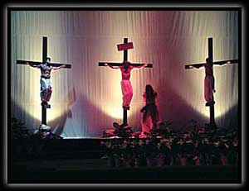
OPENING PRAYER (Psalm 122)

Leader: I was glad when they said to me,
“Let us go to the house of the Lord!”

All: Our feet are standing
within your gates, O Jerusalem!

Leader: As it was decreed for Israel,
to give thanks to the name of the Lord.

All: For there the thrones for judgment were set up.
AMEN

LISTENING TO THE WORD

Gospel Reading – Luke 23:35-43
God’s own Son, hanging on a tree with the inscription “King of the Jews” does not produce automatic faith/assent. Two groups are at the foot of the cross: those who recognize Jesus as King, and those who oppose and taunt him. We find both believers and opponents hanging next to and standing below the cross. This scene is a summary of Luke’s entire Gospel: Jesus offers salvation and reaches out to those who ask, and who recognize their need for redemption. Thus, even though Jesus’ kingship exists on a cosmic level, it is an established fact: in this life only our assent in faith reveals that kingship.
- When have you “stood at the foot of the cross” and doubted, questioned?
- What does the title “Christ the King” mean to you?
- Where in the world, our larger world, do we see signs of Christ’s kingdom being built?

LIVING THE WORD

What action can I/we undertake this week to respond to God’s Word? This week take 20 minutes to hold, look at and meditate upon the cross.

PRAYING THE WORD

Intercession: For faith in times of pain, for those who are martyred for their faith in Jesus our King, for wisdom to perceive the redeeming power of the cross in the world.
We pray to the Lord.

(Invite others to voice prayers, then end with “Our Father…”)

CONCLUDING PRAYER

Leader: Lord Jesus, King of the Universe,
master of the beginning and the end,
the Alpha and the Omega.

All: We acknowledge our need for redemption
and profess your sovereign power
in the scandal of the cross.

Leader: By revealing your royal power
in the weakness of suffering and death
you showed us the image of the invisible God.

All: Jesus, remember us,
when you come into your kingdom.
AMEN

Let us offer one another the peace of Christ, a peace the world can not give.

