Cycle A – Second Sunday of Advent, Dec. 7, 2025

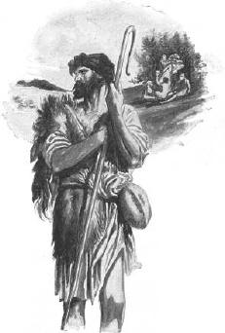“Repent for the kingdom of heaven has come near”

OPENING PRAYER (Psalm 72)
Leader: In the Lord’s days may righteousness flourish
and peace abound, until the moon is no more.

All: May he have dominion from sea to sea,
and from the river to the ends of the earth.

Leader: For God delivers the needy when they call,
the poor and those who have no helper.

All: God has pity on the weak and the needy,
and saves the lives of the needy.
Amen

LISTENING TO THE WORD

Gospel – Matthew 3:1-12

The Advent season easily has us focus on the coming of the infant Messiah. However, John the Baptist’s words clearly refer to the coming of an adult Messiah. Everything about John the Baptist challenges established religious authorities. He emerged from the desert, he wore tattered clothing and ate locusts and wild honey. John calls people not only to repentance, but to an integrity that bears the fruit of love and mercy.

- How would we respond to a John the Baptist today? Who among us really wants to make changes in her/his life?
- In what ways does our behaviour show that we repent and believe God’s Good News?
- Much in life is urgent, but not essential. Do John’s words feel urgent or essential?

LIVING THE WORD
What is God’s challenge for me/us this coming week?

PRAYING THE WORD
Intercession: For those who are missioned to issue God’s call for repentance in our churches, our communities and our world, at the risks of not being heard, of being ridiculed, or of being persecuted.
We pray to the Lord.

Invite other intentions, end with “Our Father …”)

CLOSING PRAYER

Leader: Let us pray: O Christ, Word made Flesh
You entered into our humanness, becoming one of us.

All: You reveal to us the meaning of life itself.
You have come to teach us to hope and renew us in hope.

Leader: May our lives, illumined by the radiance of your life,
become a gift to others as we continue to work for peace. Amen.

Let us share with one another a sign of peace: a peace the world cannot give.

